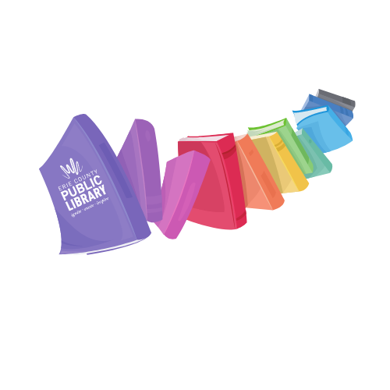

Pride

@ your library

Join TAB in celebrating LGBTQ PRIDE month at the library.  We are giving teens the opportunity to connect and celebrate PRIDE in their own way. We will supply the materials for you to create chalk art for PRIDE month.  You can chalk an LGBTQ flag, help color our PRIDE mural, or submit your own design to celebrate, honor and highlight LGBTQ history and achievements. There will be music, dancing and bubbles!  We will have colorful freeze pops and water to help you stay hydrated. You can make a button or take a spin on the Rainbow Prize Wheel and win some fabulous PRIDE bling or LGBTQ+ books.

This event is free and open to all teens age 13-18 years old. No registration.

**RAIN LOCATION: Teen Space from 2-4 PM**.

*For more information:*

*Email:* [TeenSpace@eriecountypa.gov](mailto:TeenSpace@eriecountypa.gov)

*Call:* (814) 451-6904

*Visit:* ErieLibrary.org

Saturday, June 11

1-4 PM

Behind Blasco

Rain location: Teen Space from 2-4 PM