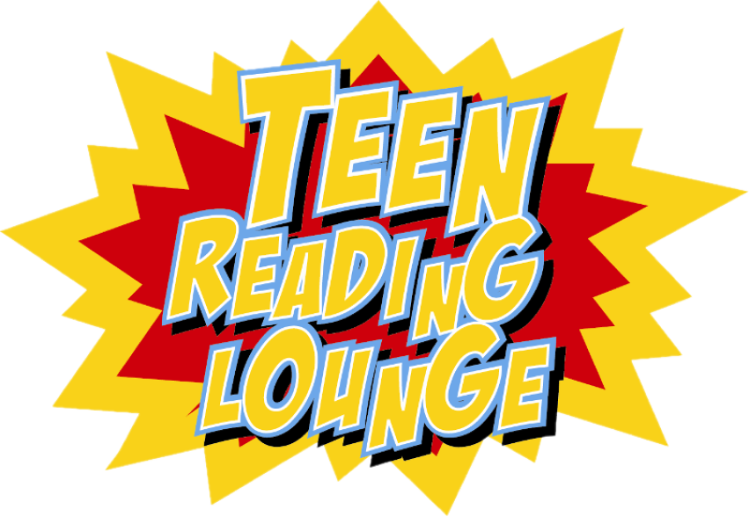

Mondays

Nov 22

Dec 6, 13, 20

Jan 3, 10

6-8 PM

Teen Space

Via Zoom

Teen Reading Lounge is an interactive book club for teens ages 13-18 in grades 8-12. This is not your average book club. Get to know more about yourself, others and the world around you through discussion and stories with a focus on the humanities. The books are yours to keep. Free. Ages 13-18. Space is limited. **Register today**.

For more information: contact the Teen Services at 814-451-6904.

Teen Reading Lounge is a program of the Pennsylvania Humanities Council, supported by the National Endowment for the Humanities and by Federal Library Services and Technology Act (LSTA) funds administered by the Office of the Commonwealth Libraries.

Teen Reading Lounge