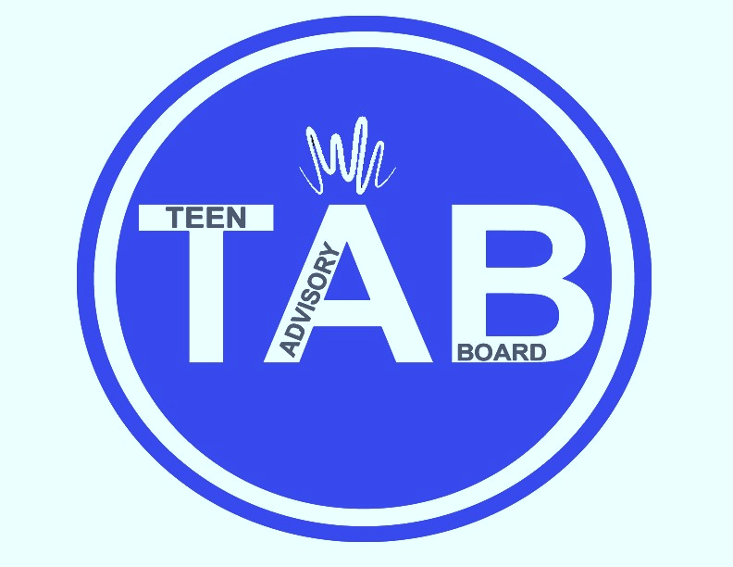

**Have fun, get involved, and make a difference at the library! TAB members meet once monthly to give input about new books, programs and services for teens. All teens are welcome to attend meetings. TAB is open to ages 13-18 years old in grades 8-12.**

***TAB programs are supported by the Friends of the Library.***

Saturday

APRIL 1, 2023

2 PM – 4 PM

Blasco Teen Space

teen advisory board

For more information:

*call* (814) 451-6904

*email* TeenSpace@eriecountypa.gov

*or visit* ErieLibrary.org.

For more information:

*call* (814) 451-6904

*email* TeenSpace@eriecountypa.gov

*or visit* ErieLibrary.org.