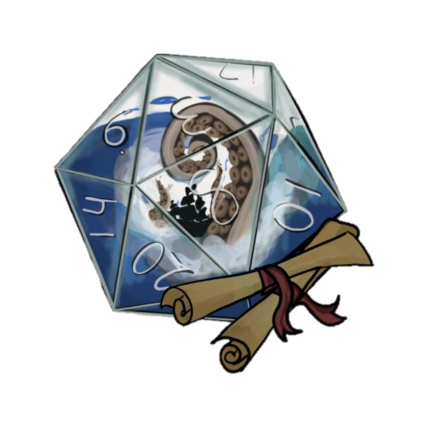

Roll some dice and join us on a grand maritime adventure! The core of D&D is storytelling. You and your friends tell a story together and guide your heroes through quests. You will develop your character and participate in a full pirate-themed campaign. Beginner edition. No prior D&D experience is necessary. Free. Age 13-18 years old. Register requested.

Play Like a Pirate

THURSDAYS

June 23

July 7 and 21

August 4 and 18

2:30 to 4:30 PM

Blasco, Teen Space

DUNGEONS & DRAGONS

For more information:

*call* (814) 451-6904

*email* TeenSpace@eriecountypa.gov

*or visit* ErieLibrary.org.



Roll some dice and join us on a grand maritime adventure! The core of D&D is storytelling. You and your friends tell a story together and guide your heroes through quests. You will develop your character and participate in a full pirate-themed campaign. Beginner edition. No prior D&D experience is necessary. Free. Age 13-18 years old. Register requested.

Play Like a Pirate

THURSDAYS

June 23

July 7 and 21

August 4 and 18

2:30 to 4:30 PM

Blasco, Teen Space

DUNGEONS & DRAGONS

For more information:

*call* (814) 451-6904

*email* TeenSpace@eriecountypa.gov

*or visit* ErieLibrary.org.



Roll some dice and join us on a grand maritime adventure! The core of D&D is storytelling. You and your friends tell a story together and guide your heroes through quests. You will develop your character and participate in a full pirate-themed campaign. Beginner edition. No prior D&D experience is necessary. Free. Age 13-18 years old. Register requested.

Play Like a Pirate

THURSDAYS

June 23

July 7 and 21

August 4 and 18

2:30 to 4:30 PM

Blasco, Teen Space

DUNGEONS & DRAGONS

For more information:

*call* (814) 451-6904

*email* TeenSpace@eriecountypa.gov

*or visit* ErieLibrary.org.



Roll some dice and join us on a grand maritime adventure! The core of D&D is storytelling. You and your friends tell a story together and guide your heroes through quests. You will develop your character and participate in a full pirate-themed campaign. Beginner edition. No prior D&D experience is necessary. Free. Age 13-18 years old. Register requested.

Play Like a Pirate

THURSDAYS

June 23

July 7 and 21

August 4 and 18

2:30 to 4:30 PM

Blasco, Teen Space

DUNGEONS & DRAGONS

For more information:

*call* (814) 451-6904

*email* TeenSpace@eriecountypa.gov

*or visit* ErieLibrary.org.