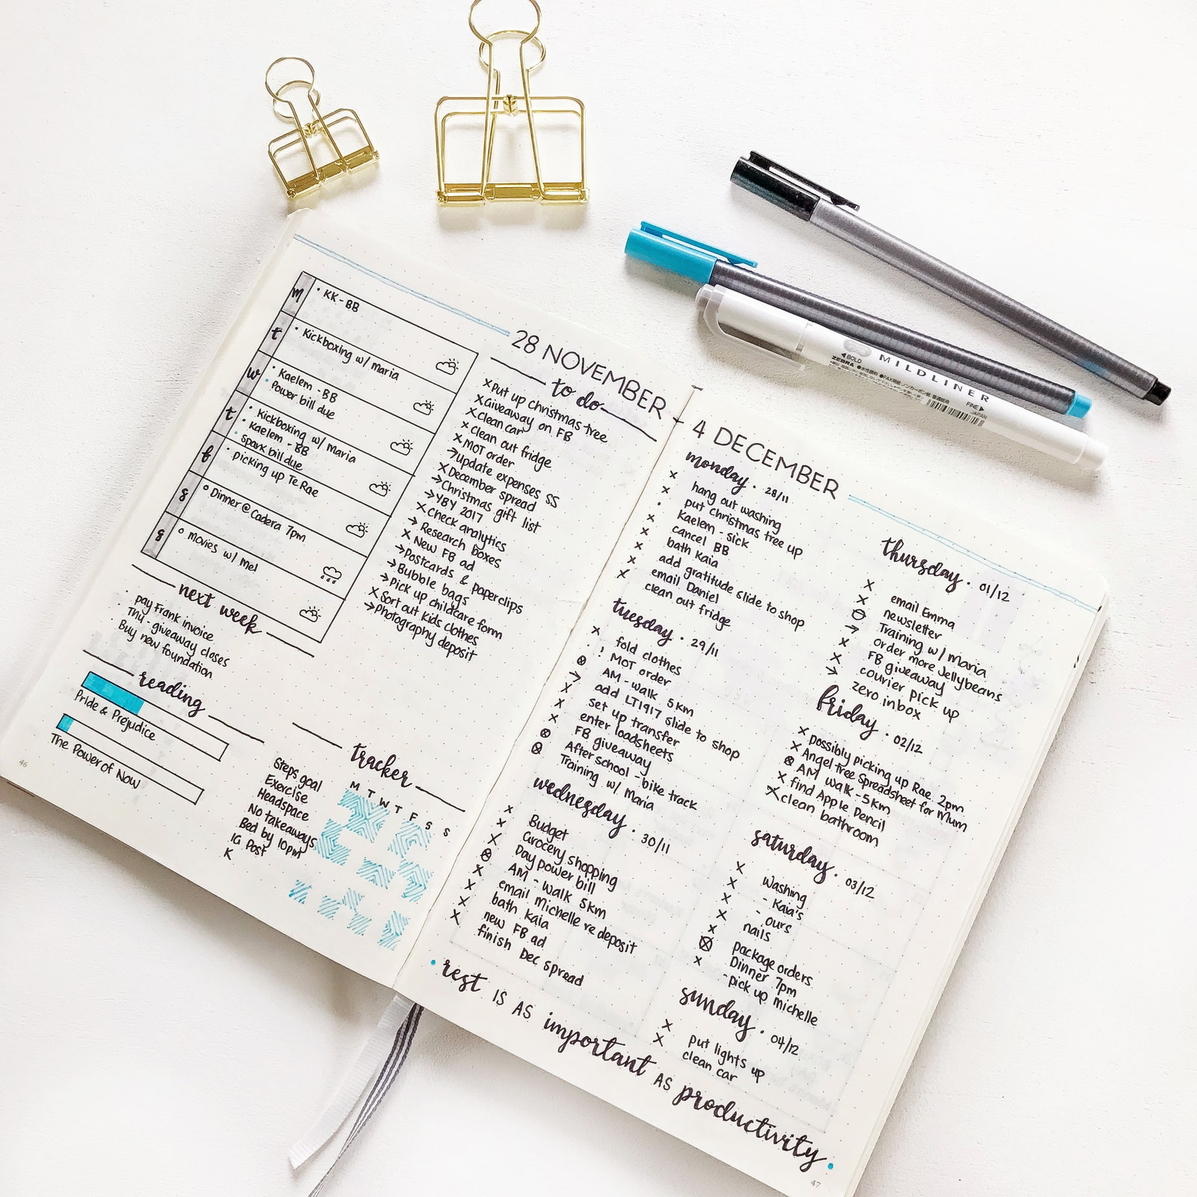 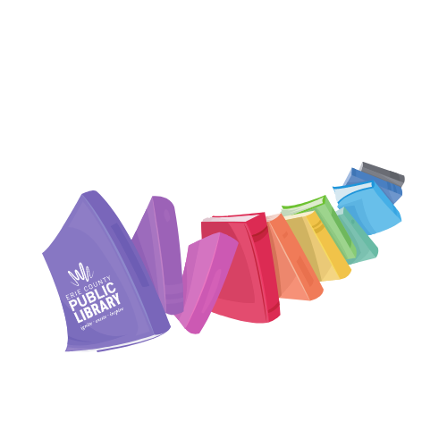

Do you want to learn how to plan, track and keep a record of activities in a fun and unique way? Bullet journals can help you do just that. This is a hands on workshop to get you started. We will supply the materials, demonstrate key concepts and help you create. Each participant will get a journal, pens, stencils, and stickers to keep.

This is an in-person event. For your safety and ours, masks are still required.  Free for teens age 13-18 years old. Registration is preferred.

**Beginner How To**

Bullet journals

Thursdays

Dec. 2, 9 and 16, 2021

6:00 PM – 8:00 PM

Blasco Teen Space

For more information:

*call* (814) 451-6904

*email* TeenSpace@eriecountypa.gov

*or visit* ErieLibrary.org.

For more information:

*call* (814) 451-6904

*email* TeenSpace@eriecountypa.gov

*or visit* ErieLibrary.org.