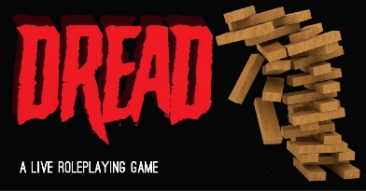

For more information:

*call* (814) 451-6904

*email* TeenSpace@eriecountypa.gov

*or visit* ErieLibrary.org.

Thursday

October 20th, 2022

6:30 PM – 7:30 PM

Blasco Teen Space

Games that go bump in the night. Join us for the horror role playing game, Dread. We will play a round and then give some suggestions for you to make your own Dread story.

No previous experience necessary. Free for teens age 13-18 years old. Registration is required.

Program provided with generous support from the Friends of the Erie County Library.

Let’s play DRead (rpg)