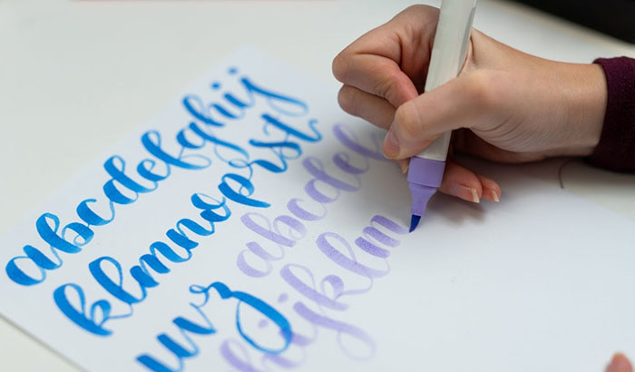

Learn the basics of calligraphy. We will have supplies on hand to get you started and make your own project.

This is an in-person event. No previous experience necessary. Free for teens age 13-18 years old. Registration is required.

Program provided with generous support from the Friends of the Erie County Library.

beginner calligraphy

Monday

October 12th, 2022

6:30 PM – 7:30 PM

Blasco Teen Space

For more information:

*call* (814) 451-6904

*email* TeenSpace@eriecountypa.gov

*or visit* ErieLibrary.org.

For more information:

*call* (814) 451-6904

*email* TeenSpace@eriecountypa.gov

*or visit* ErieLibrary.org.