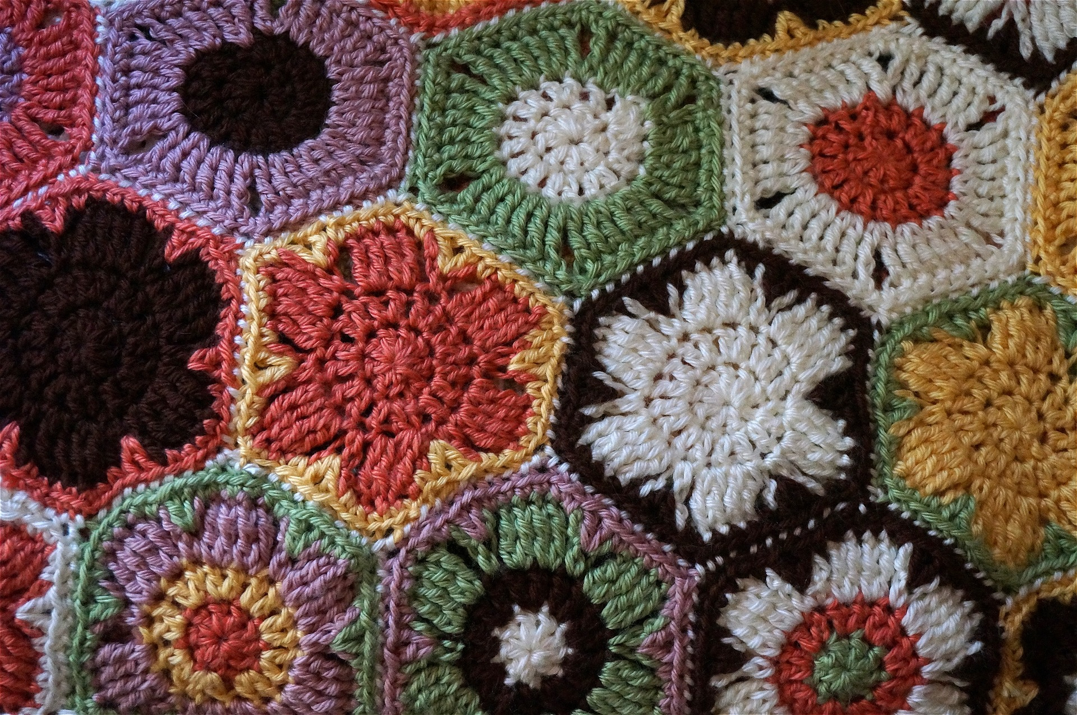
Crafting Club

Wednesdays
September 1st - December 15th 1:00 PM - 3:00 PM
Iroquois Community Room | Audience: Adults

Join fellow crafters while working on your own personal projects such as knitting, quilting and crochet. Bring your finished projects for show and tell. Those in attendance can expect good company, sharing ideas and interesting conversations.

Registration is required for this free program.
For more information, or to register please call 814.451.7082 or visit events.erielibrary.org.

Pennsylvania State and County Department of Health guidelines will be followed during this program.

