Monday Makers: Laser Cut Garden Stakes
Monday, August 22nd, 6-7PM
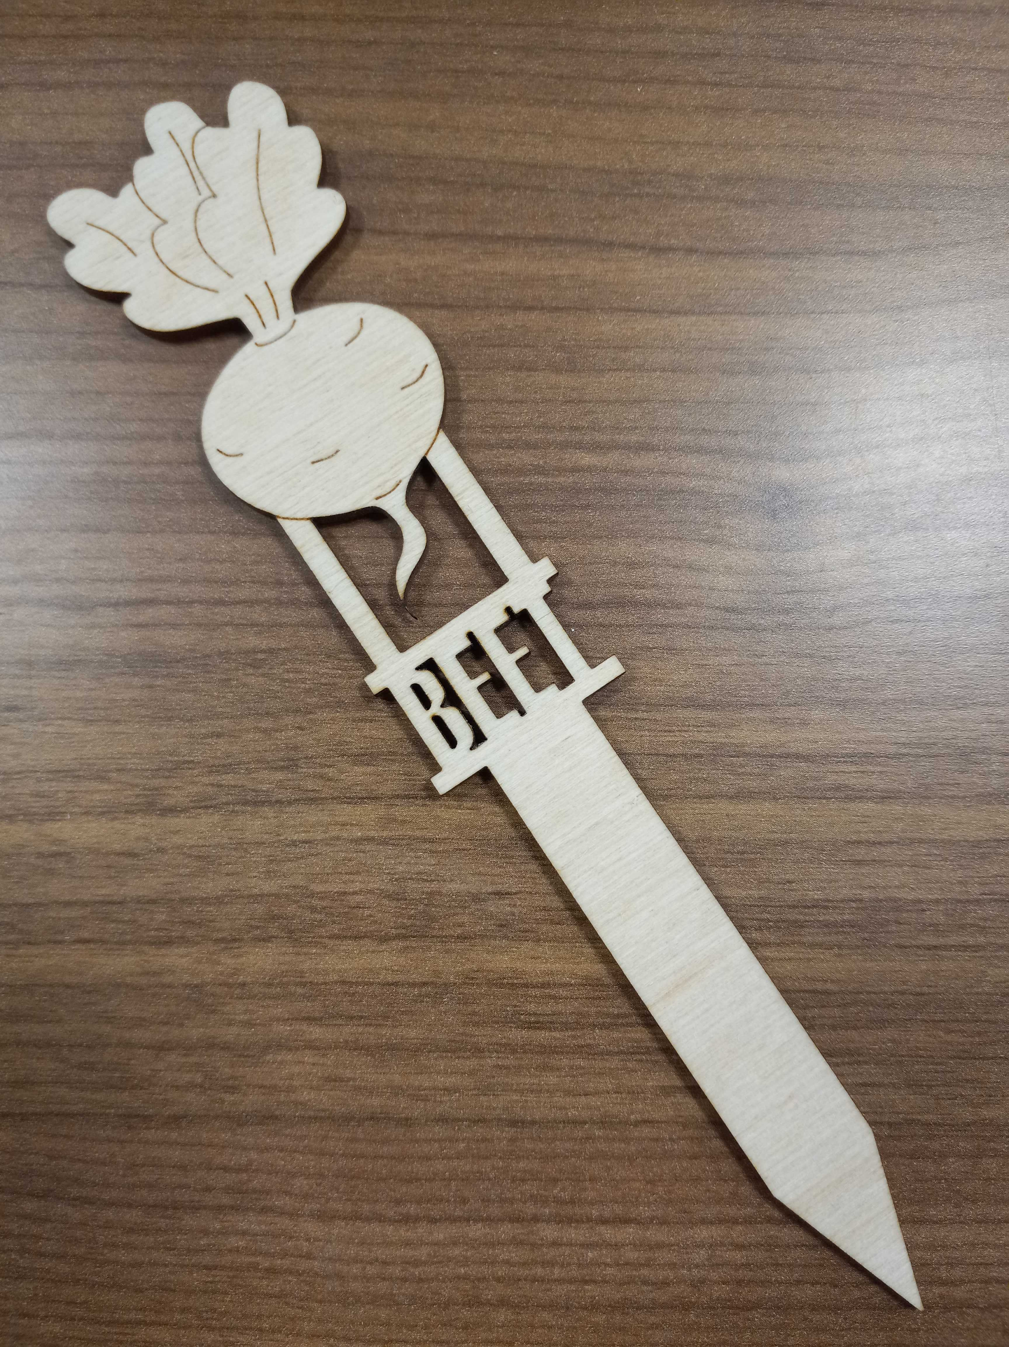
Blasco Library Idea Lab
Drop in to plant a seed from our seed library. Laser cut a garden stake to put in your pot. All ages welcome! No registration required.

