Learn to Laser Cut and Engrave
Tuesdays, 7/12, 7/19 & 7/26, 6-7:30 PM
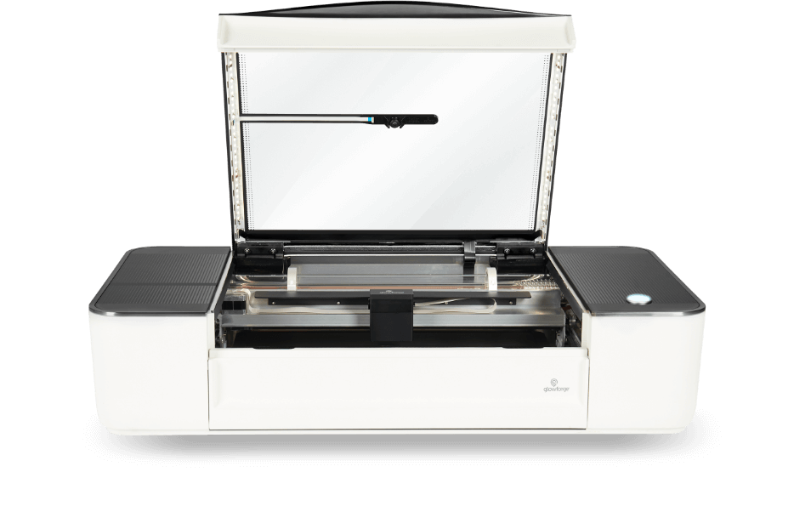
Community Classroom

Learn how to use the Idea Lab's laser cutter and engraver, the Glowforge! In this class you will learn how to safely operate the machine, where to find designs and how to use the online Glowforge App. Everyone will also get a chance to make a small keychain to take with them. After taking this class, you are certified to reserve and use the Glowforge independently when the Idea Lab is open. Registration is required.

