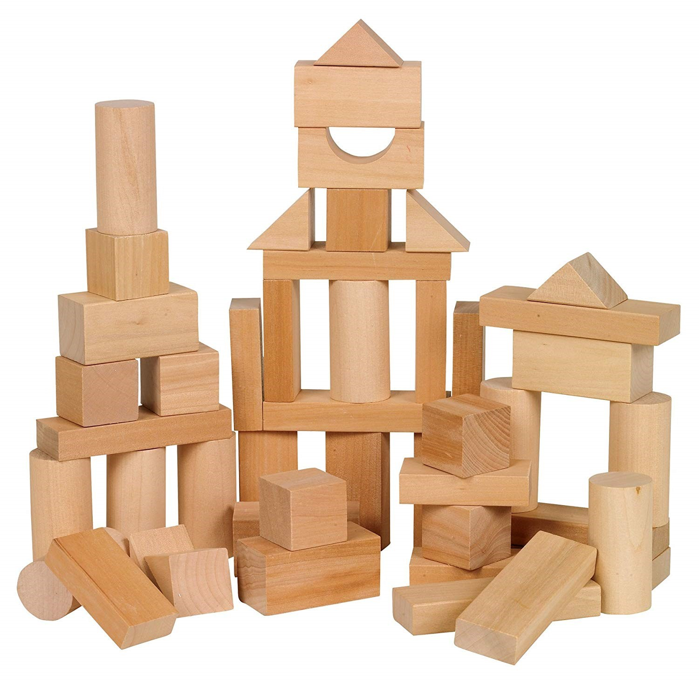
Stay and Play
Mondays
9 am-12noon
Lincoln Community Room
Families welcome, recommended ages 0-5yrs

Roll out the carpet! Stay, play, and visit. Even though there is no story time, we can always meet up at the library with friends. There will be puppets, blocks, a craft table and plenty of books to read.

We will not be meeting on July 4,September 5,October 10,

Thank you to the Friends of the Library
for making this event possible. Children twelve and under must be accompanied by an adult. Pennsylvania State and County Department of Health guidelines will be followed during this program.

