Macrame Bracelet
Tuesday, August 30th, 6-7PM
Blasco Library Idea Lab
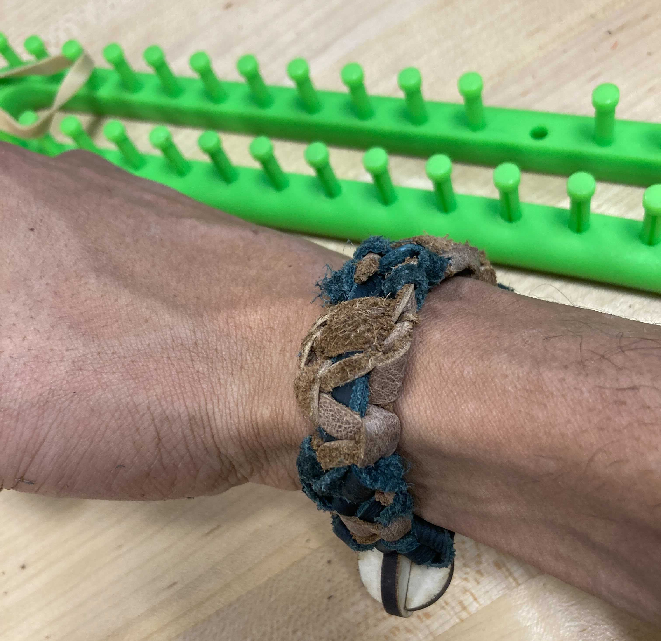
Join us for as we make a macramé bracelet out of cord. We'll learn some simple knots and use our hands to make the bracelet. No experience required and all ages are welcome! Registration required.

