rEAD TO a Therapy dog
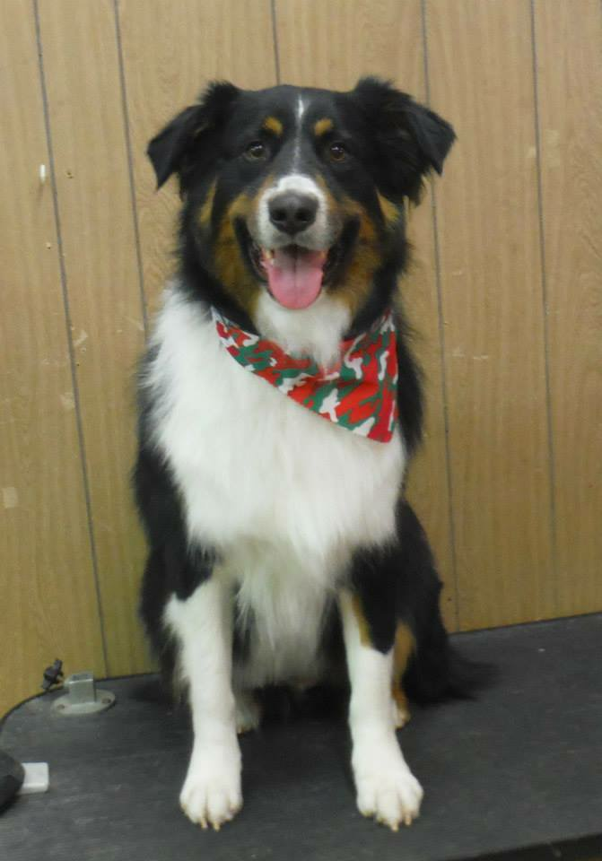
Willie Nelson - Tuesdays
10/12 & 11/ 9 | 3:30 PM
&
Sky - Tuesdays
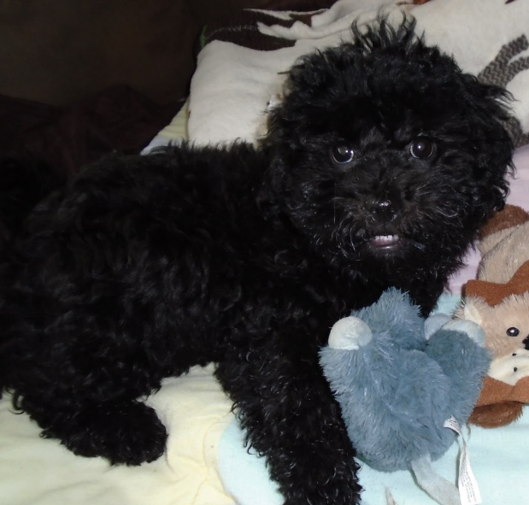
10/26 & 11/16 | 3:30 PM Edinboro Community Room

Children are invited to read to Willie Nelson or Sky, therapy dogs from Therapy Dogs United and Alliance of Therapy Dogs. Willie Nelson and Sky love to listen while children gain reading confidence!

No need to register – just come!
Pennsylvania State and County Department of Health guidelines will be followed during this program.
This program is sponsored by the Friends of the Erie County Public Library.

rEAD TO a Therapy dog
Willie Nelson - Tuesdays
10/12 & 11/ 9 | 3:30 PM
&
Sky - Tuesdays
10/26 & 11/16 | 3:30 PM Edinboro Community Room

Children are invited to read to Willie Nelson or Sky, therapy dogs from Therapy Dogs United and Alliance of Therapy Dogs. Willie Nelson and Sky love to listen while children gain reading confidence!

No need to register – just come!
Pennsylvania State and County Department of Health guidelines will be followed during this program.
This program is sponsored by the Friends of the Erie County Public Library.

rEAD TO a Therapy dog
Willie Nelson - Tuesdays
10/12 & 11/ 9 | 3:30 PM
&
Sky - Tuesdays
10/26 & 11/16 | 3:30 PM Edinboro Community Room

Children are invited to read to Willie Nelson or Sky, therapy dogs from Therapy Dogs United and Alliance of Therapy Dogs. Willie Nelson and Sky love to listen while children gain reading confidence!

No need to register – just come!
Pennsylvania State and County Department of Health guidelines will be followed during this program.
This program is sponsored by the Friends of the Erie County Public Library.

rEAD TO a Therapy dog
Willie Nelson - Tuesdays
10/12 & 11/ 9 | 3:30 PM
&
Sky - Tuesdays
10/26 & 11/16 | 3:30 PM Edinboro Community Room

Children are invited to read to Willie Nelson or Sky, therapy dogs from Therapy Dogs United and Alliance of Therapy Dogs. Willie Nelson and Sky love to listen while children gain reading confidence!

No need to register – just come!
Pennsylvania State and County Department of Health guidelines will be followed during this program.
This program is sponsored by the Friends of the Erie County Public Library.

