Monday Makers: Make a terrarium
Monday, August 29th, 6-7PM
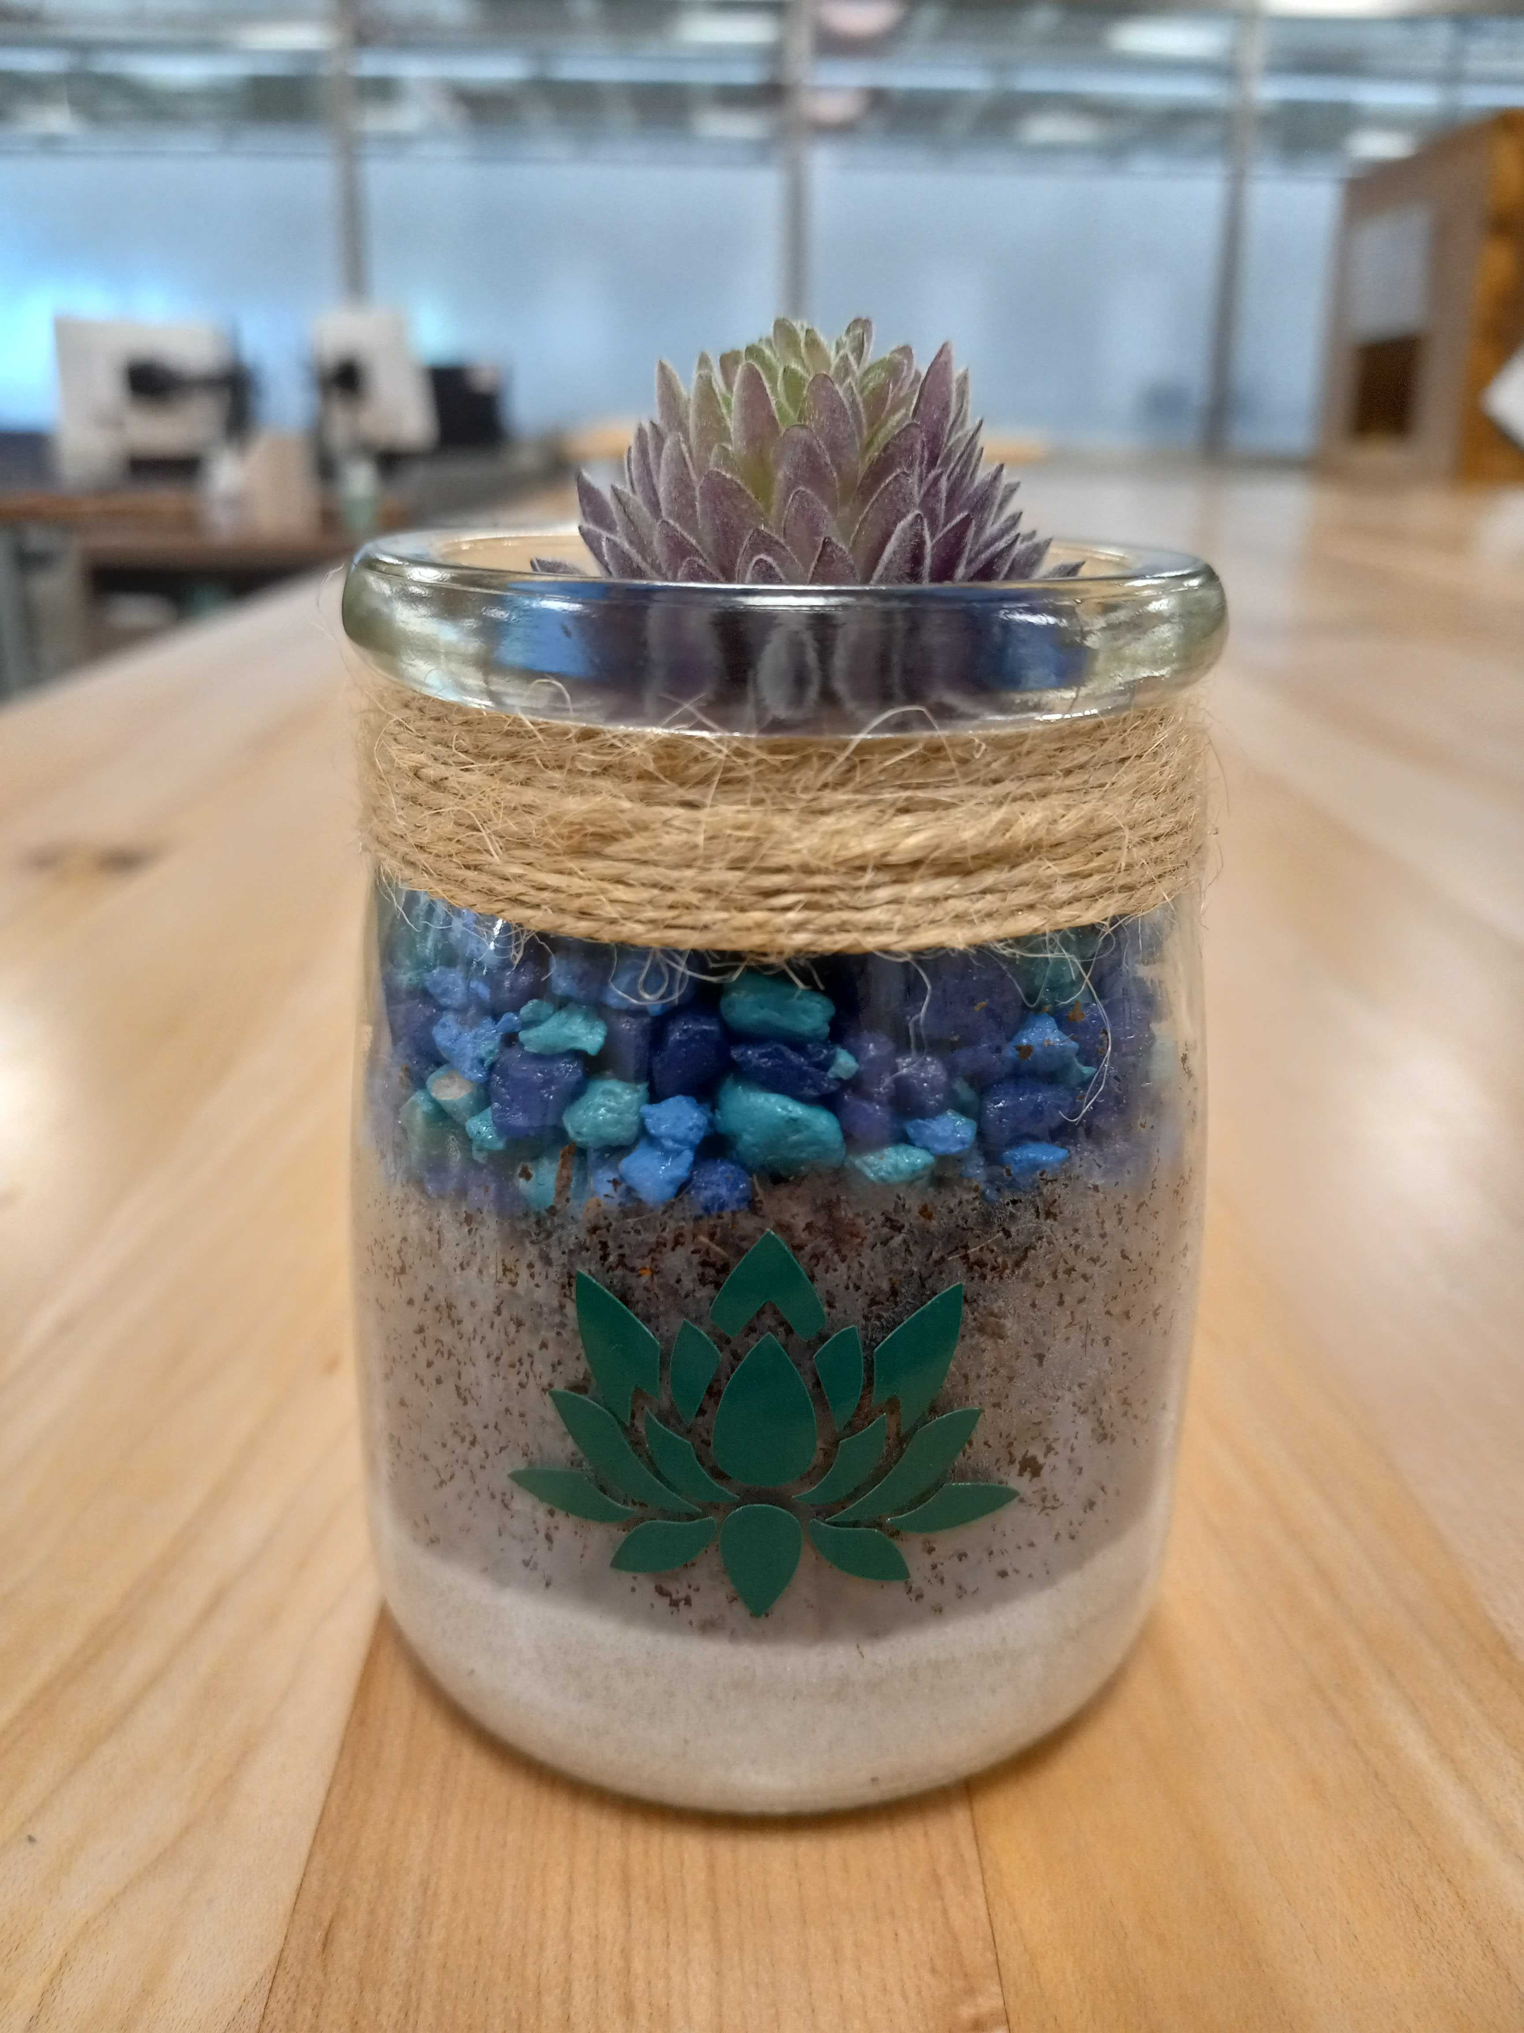
Blasco Library Idea Lab
Make a small terrarium with a faux succulent. Use moss, stones, sand or soil to create layers in the jar. Add stickers cut from the Circuit to decorate the glass. All ages welcome! Registration required.

